SIMATS ENGINEERING (SAVEETHA SCHOOL OF ENGINEERING)
Department of Computer Science and Engineering
ASSESSMENT TOOL 2 – Short Answer

Course Code: | ITA0304 | Course Title: | Mobile computing
CO Assessed: | CO1 | Assessment: | Assessment Tool 2 – Short Answer
Weightage: | 30 % of CIA | Total Marks: | 100 Marks
CO1 Statement: | Analyze the mobile network components, mobile base station, mobile infrastructures and protocols in cellular systems.
Student Name: | MUTHUPRIYA R | Reg. No.: | 192421002
Section / Batch: | C | Date: | 23.07.2026

Code of Conduct
I MUTHUPRIYA R (192421002) certify that this submission is my original work and that I have adhered to the guidelines specified for this assessment. I understand that any violation of academic integrity rules will result in disciplinary action.
Signature of the Student: __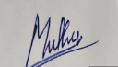

Instructions
- This test contains 50 questions, Total: 100 Marks.
- Duration: 1 hour.

Questions

Q1. A telecom operator wins a spectrum auction for 45 MHz. Company policy sets aside 25 kHz for every simplex channel. The planning team wants to know how many full-duplex voice channels this spectrum can support.
Q2. A regional carrier runs its network on 560 total voice channels, shared across a 7-cell frequency reuse cluster. During capacity planning, an engineer needs to know how many channels a single cell will typically be allocated.
Q3. A GSM operator sets carrier spacing at 200 kHz and rolls out 100 carriers, each carrying 8 time slots for voice traffic. Determine the total number of simultaneous voice channels this deployment can offer.
Q4. During a site audit, engineers note the base station radiates 80 W while a nearby handset transmits just 4 W. They want to express this power gap as a decibel-based power control ratio (10·log10 of the ratio).
Q5. A drive test captures a serving signal at -60 dBm alongside co-channel interference at -92 dBm. The RF team needs the Carrier-to-Interference ratio (C/I) in dB to assess link quality.
Q6. An operator holds 42 MHz of spectrum, assigning 300 kHz per channel, and reuses frequencies across a 7-cell pattern. How many channels does a single cell end up with?
Q7. A transmitter delivers 64 W of power to a receiver. Engineers then move the receiver twice as far away, in an environment with a path-loss exponent of 4. What received power should they now expect?
Q8. Planners want to double a cell's radius while keeping the same SNR at the new edge, in an environment obeying an inverse-square power law. By what factor should transmit power be scaled up?
Q9. A network is built with a cluster size of 4, and every cell in the cluster is provisioned with 15 voice channels. What is the total channel count across the entire cluster?
Q10. A drive test records a vehicle traveling at 100 km/h while camped on a 900 MHz carrier. Estimate the Doppler shift the receiver experiences.
Q11. A TDMA frame lasting 5 ms is divided into 8 equal time slots. What is the duration of a single slot?
Q12. Spectrum planners have 24 MHz of allocated bandwidth and fix carrier spacing at 200 kHz for a GSM rollout. How many carrier frequencies can be created from this allocation?
Q13. A handset transmits at 8 W, but the signal experiences 33 dB of path loss on its way to the base station. Estimate the power the base station receiver actually sees, in dBm.
Q14. A network engineer uses 1 m as the reference distance while assessing a 1900 MHz deployment, where cell sites are spaced 2.5 km apart. Estimate the free-space path loss over that distance.
Q15. A cluster consists of 6 cells, each able to carry up to 250 simultaneous calls at peak. What is the cluster's total call-handling capacity?
Q16. A switching subsystem is rated to process 4000 new call requests every second, and calls last 3 minutes on average. How many calls could be active in the system at any one time?
Q17. Engineers assign 150 channels to a base station subsystem, each channel occupying 25 kHz. What total bandwidth does this base station consume?
Q18. Spectrum planners insert a 40 kHz guard band between each of 30 adjacent frequency bands to prevent interference. How much total bandwidth ends up wasted because of these guard bands?
Q19. A vehicle cruises at 90 km/h through a region of 1.5 km-radius cells. Using the cell diameter as the crossing distance, roughly how many handoffs would occur over an hour of travel?
Q20. A carrier's network hierarchy has 8 regional centers, each overseeing 40 base stations, with each base station serving 250 users. What is the network's total user-handling capacity?
Q21. Coverage planners want to blanket a 400 sq km region using hexagonal cells of 400 m radius (approximate cell area as R²). Roughly how many cells will the rollout require?
Q22. An FDMA system allots 30 kHz to each channel, drawing from a total spectrum pool of 6 MHz. How many channels can be carved out of this allocation?
Q23. A market study notes that 1200 subscribers each place 4 calls per hour, averaging 2.5 minutes per call. What total offered traffic, in Erlangs, does this represent?
Q24. A 2.5 GHz deployment has 40 MHz of bandwidth, and each connected user consumes 400 kHz. What is the maximum number of users the band can serve at once?
Q25. A carrier's base stations each cap out at 600 simultaneous users, and the network comprises 1200 such stations. What total user capacity does the network offer?
Q26. A paging scheme sweeps through 4 cells at a time across a 200-cell network. In the worst case, how many paging rounds are needed to locate a subscriber?
Q27. A core network is engineered for 100,000 simultaneous connections. During a busy period it receives 40,000 call attempts per minute, each lasting 3 minutes on average. What fraction of the offered traffic ends up blocked?
Q28. A network policy lets 15% of its 600,000 subscribers roam onto partner networks each hour. At any given moment, how many subscribers are likely roaming?
Q29. A switching center is capable of processing 12,000 calls per second, but is currently handling a peak load of 9,000 calls per second. What percentage of its capacity is being utilized?
Q30. An operator reuses frequencies with a factor of 4 across a network holding 48 MHz of spectrum, with 200 kHz per channel. How many channels land in each cell?
Q31. A 900 MHz GSM deployment uses 200 kHz channel spacing across a 30 MHz allocation. How many channels can this spectrum support?
Q32. Over the course of an hour, a network logs 2500 handoff attempts, 99% of which succeed. How many calls were successfully handed off?
Q33. A mobile handset radiates 12 W, and the link experiences 45 dB of path loss before reaching the base station. What power level does the base station receiver detect?
Q34. A 7-cell cluster is deployed where each cell can serve up to 900 simultaneous users. What is the cluster's overall user capacity?
Q35. A TDMA carrier's frame spans 4.8 ms and is split into 8 equal slots. How long is each individual slot?
Q36. A mobile device moves at 150 km/h while connected to a 1.8 GHz carrier. What Doppler shift should the receiver expect?
Q37. A core switch is dimensioned for 250,000 simultaneous calls. It is fielding calls at a rate of 70,000 per minute, each averaging 4 minutes in duration. What share of the offered load gets blocked?
Q38. A hexagonal layout groups 9 cells into a cluster, and each cell can host 600 users. What is the cluster's combined user capacity?
Q39. A switching center processes 60,000 calls per second, with 0.4% of them dropped due to network issues. How many calls are being dropped every second?
Q40. A base station in an 1800 MHz network transmits at 43 dBm. At the edge of its 2 km-radius cell, the received signal measures -87 dBm. What path loss has the signal undergone?
Q41. A single base station covers 2.5 km² of territory, and the operator plans to deploy 150 identical stations. What total geographic area will the rollout cover?
Q42. An operator applies a frequency reuse factor of 6 over a 48 MHz spectrum allocation, with each channel taking up 200 kHz. How many channels does each cell get?
Q43. A paging system processes 6000 users per cycle, and the subscriber base totals 150,000 users. How many paging cycles are needed to sweep the entire base?
Q44. A phone call runs for 9 minutes, and during that time the network hands the call off roughly every 3 minutes. How many handoffs took place over the call?
Q45. A receiver picks up a wanted signal at -85 dBm against a noise floor of -115 dBm. What signal-to-noise ratio, in dB, does this represent?
Q46. A 4G cell is serving 250 users simultaneously, each needing a guaranteed 150 kbps. What is the minimum bandwidth the cell must provide to support them all?
Q47. A base station handles 1500 subscribers, each averaging 4 calls per hour with a 2.5-minute call length. What total traffic, in Erlangs, does this generate?
Q48. A network reserves 250 separate control channels, each 12 kHz wide, for signaling. What total bandwidth is tied up in control channels?
Q49. A network is carrying 1500 simultaneous connections, each streaming at 600 kbps on average. What total throughput must the network support?
Q50. A telecom operator wants each tower to cover a 4 km radius (treating coverage as a circle, area = πR²) and needs to blanket a 350 km² service region. Roughly how many towers will the rollout require?

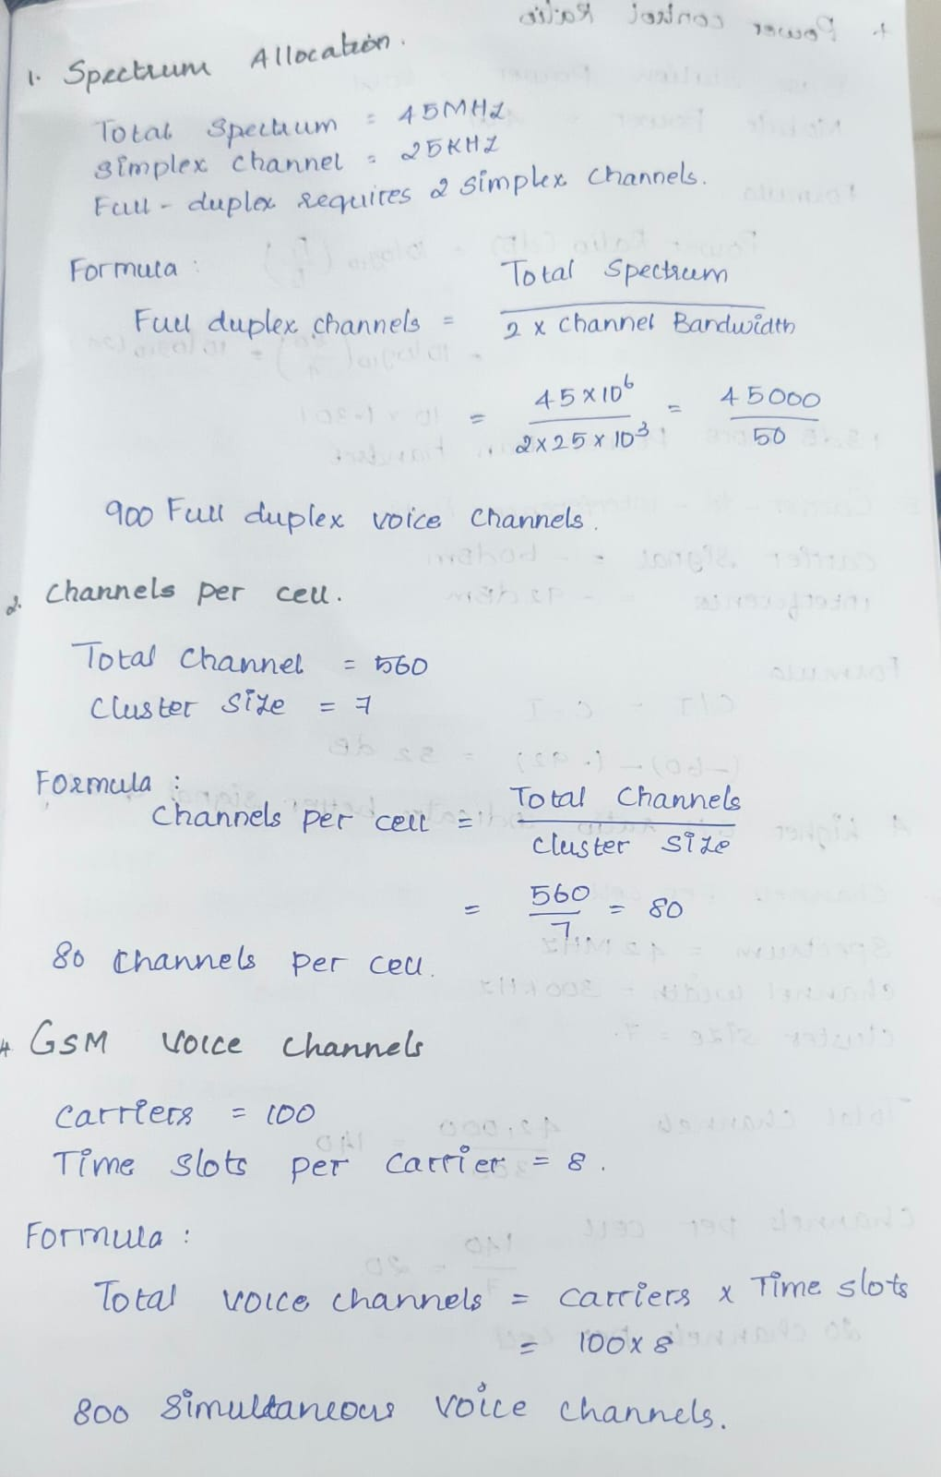
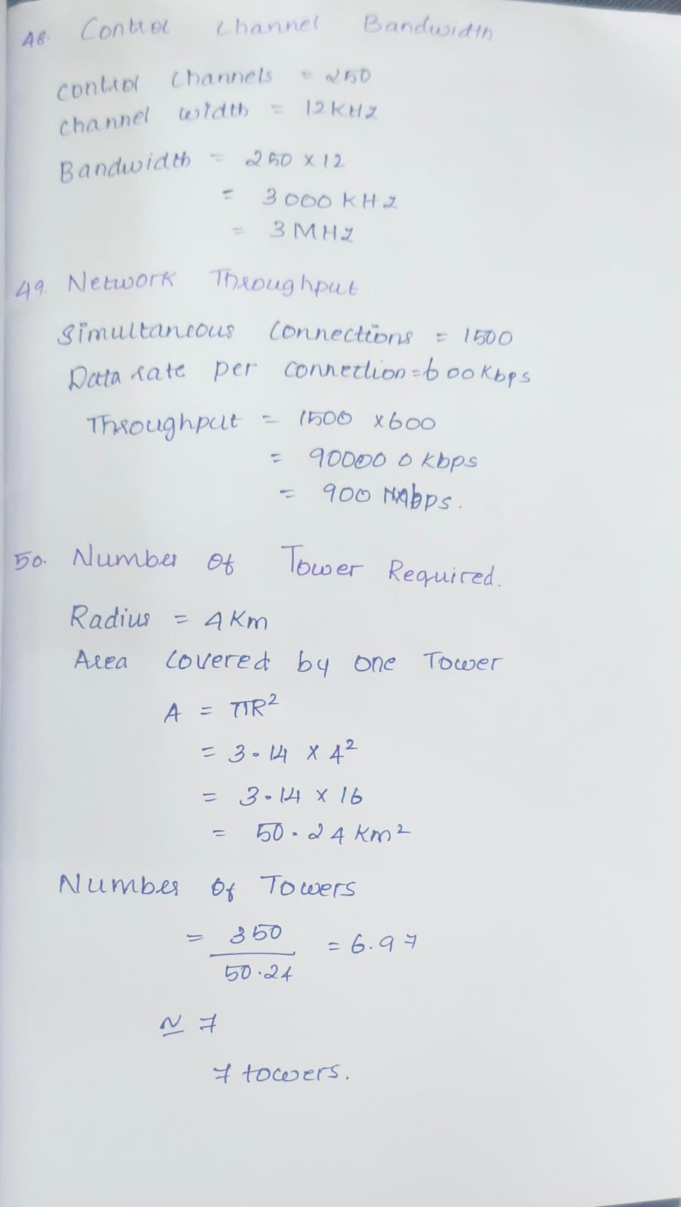
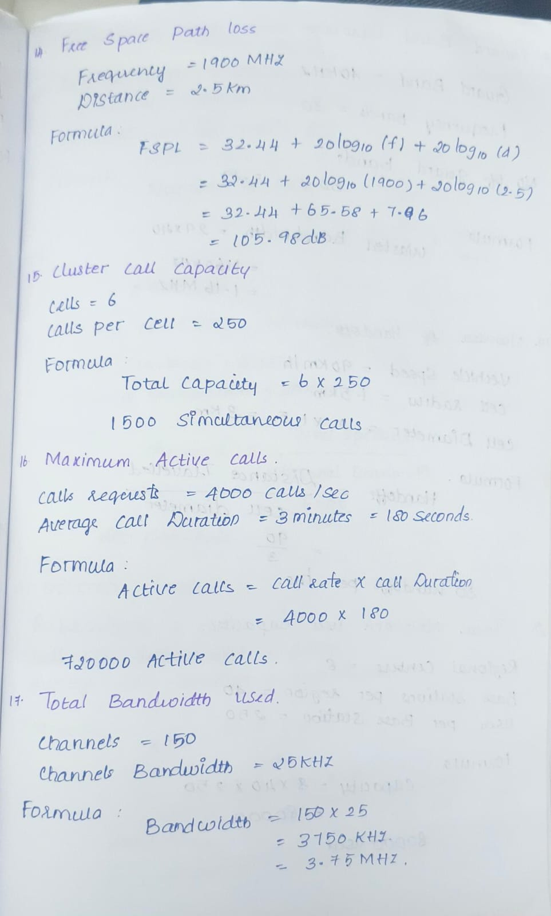
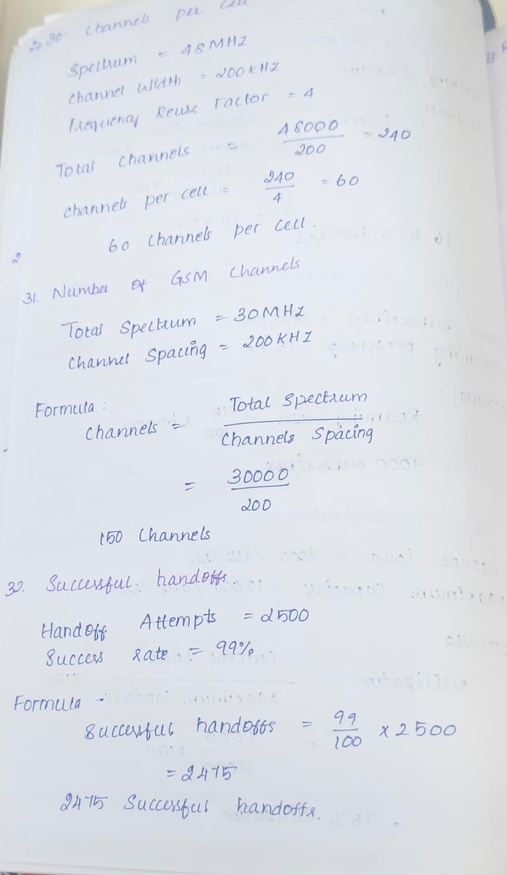
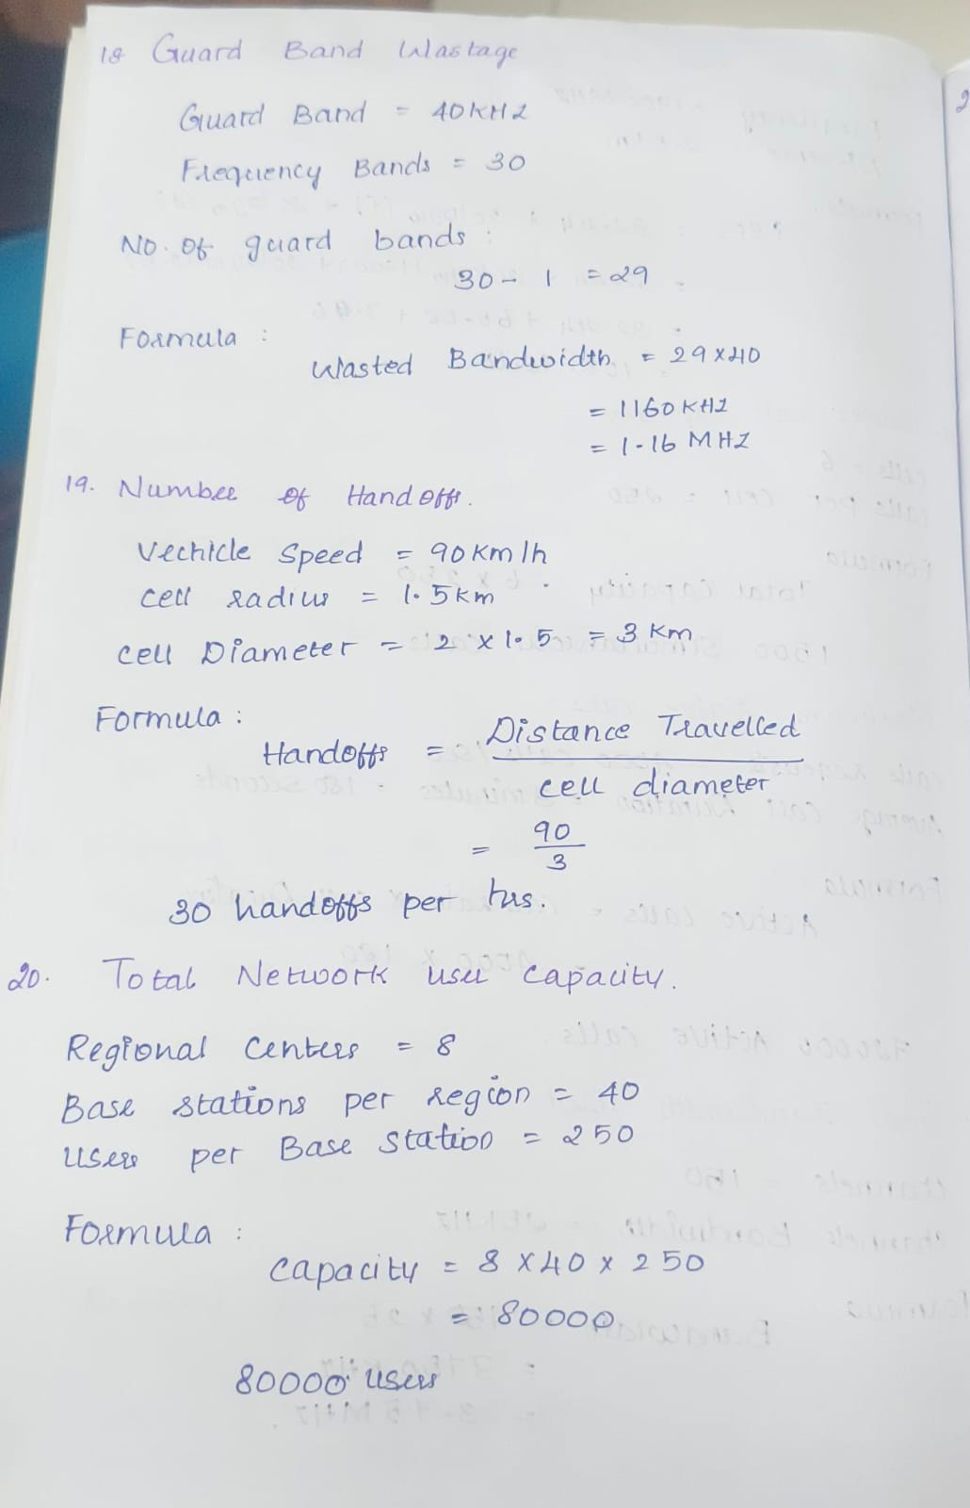
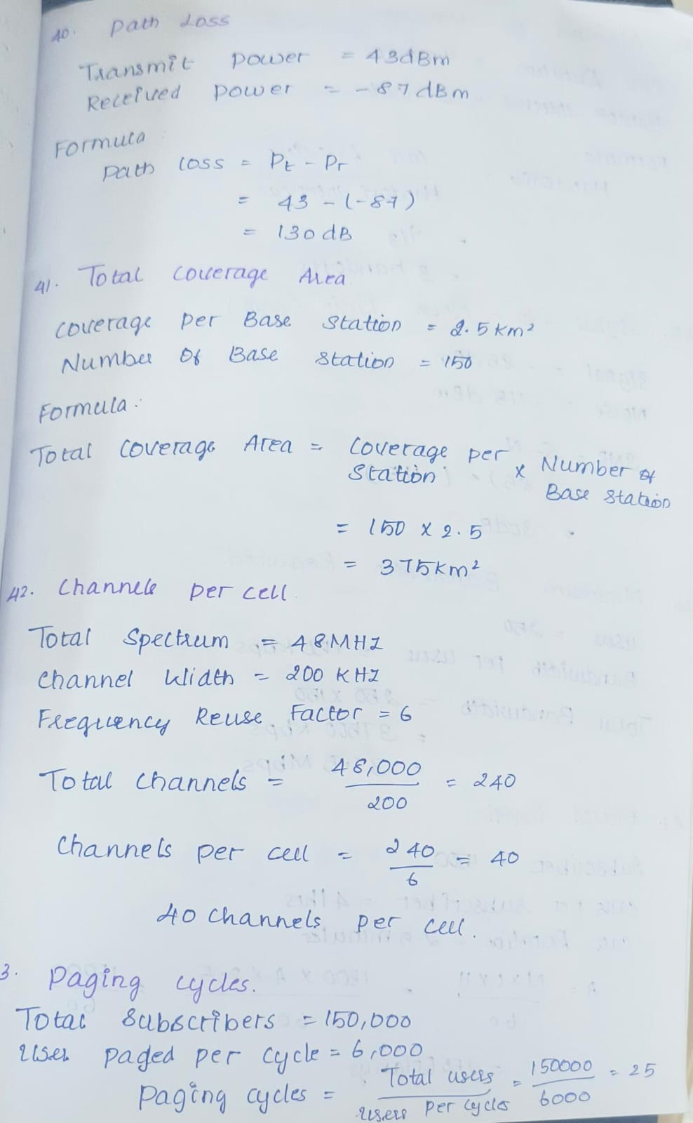
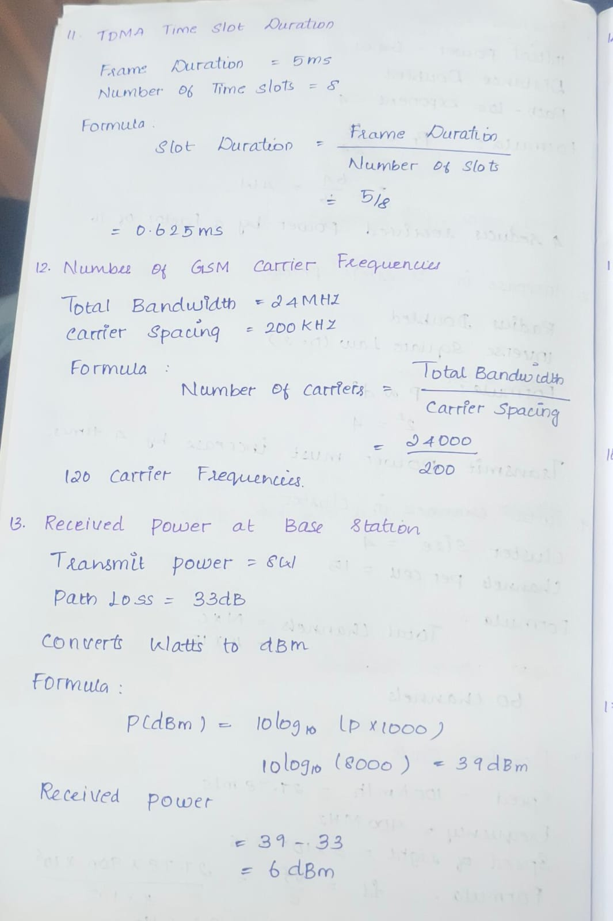
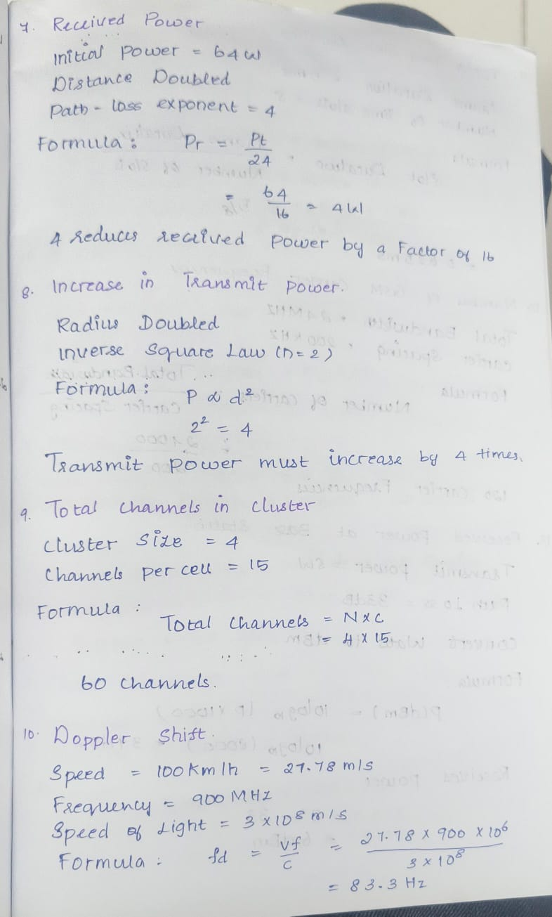
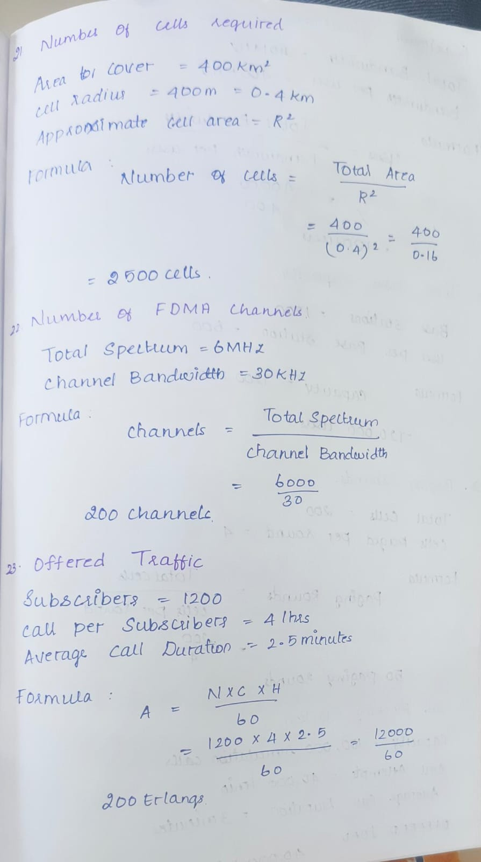
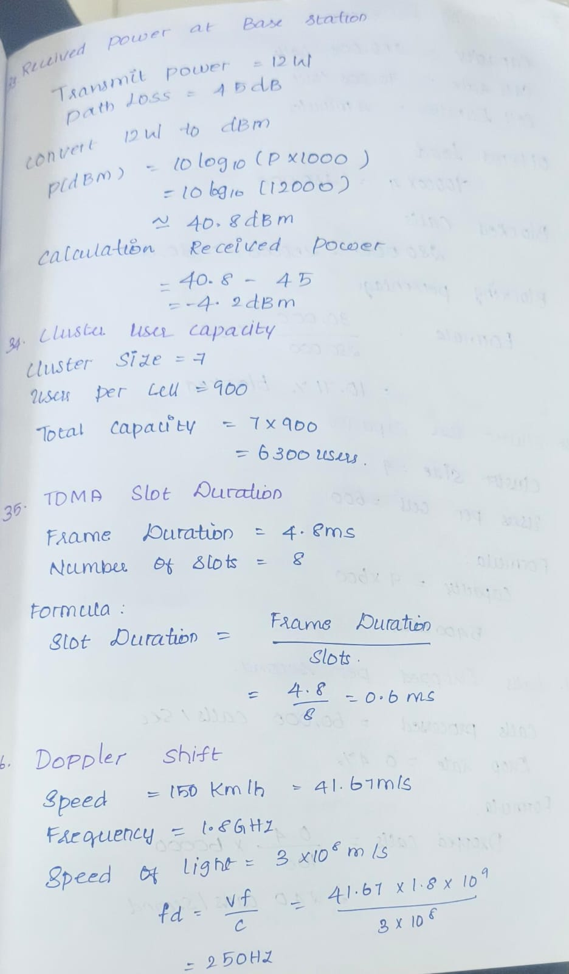
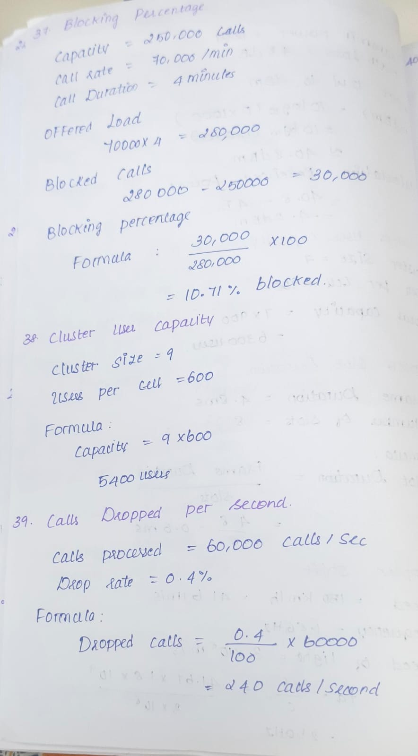
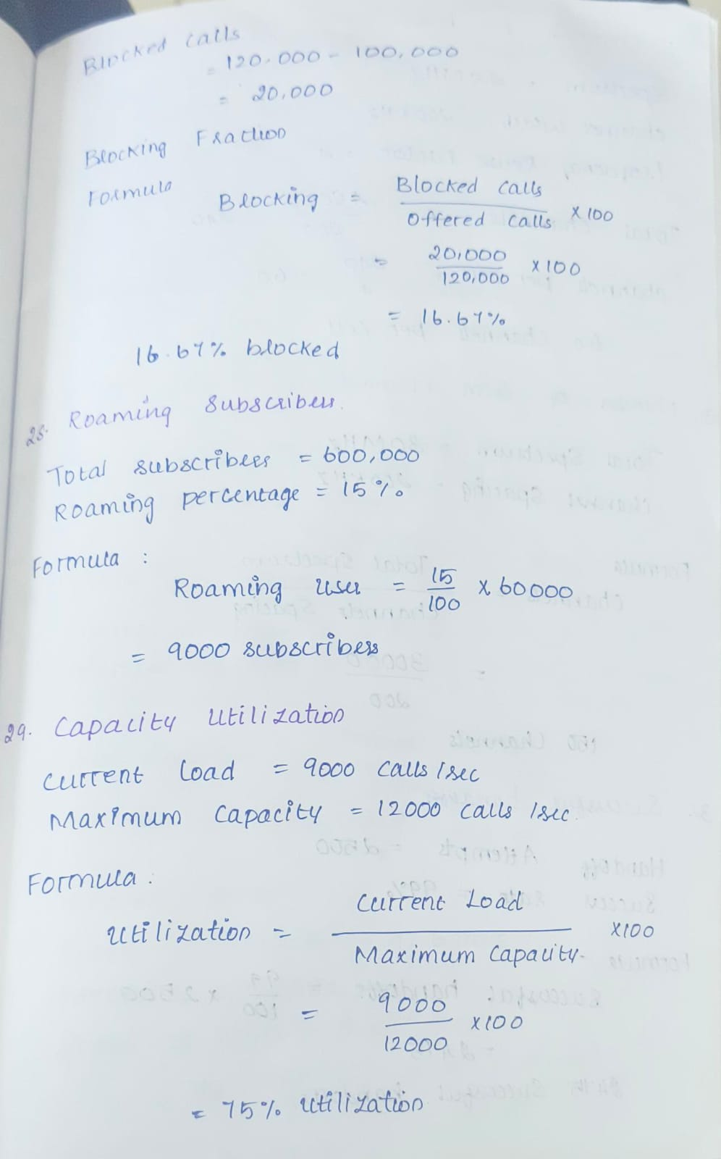
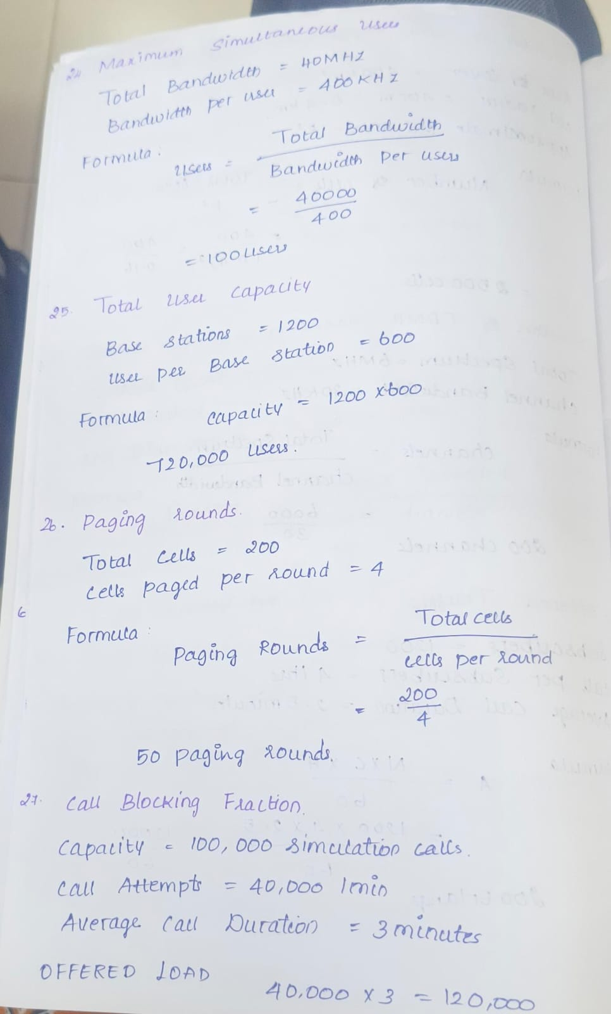
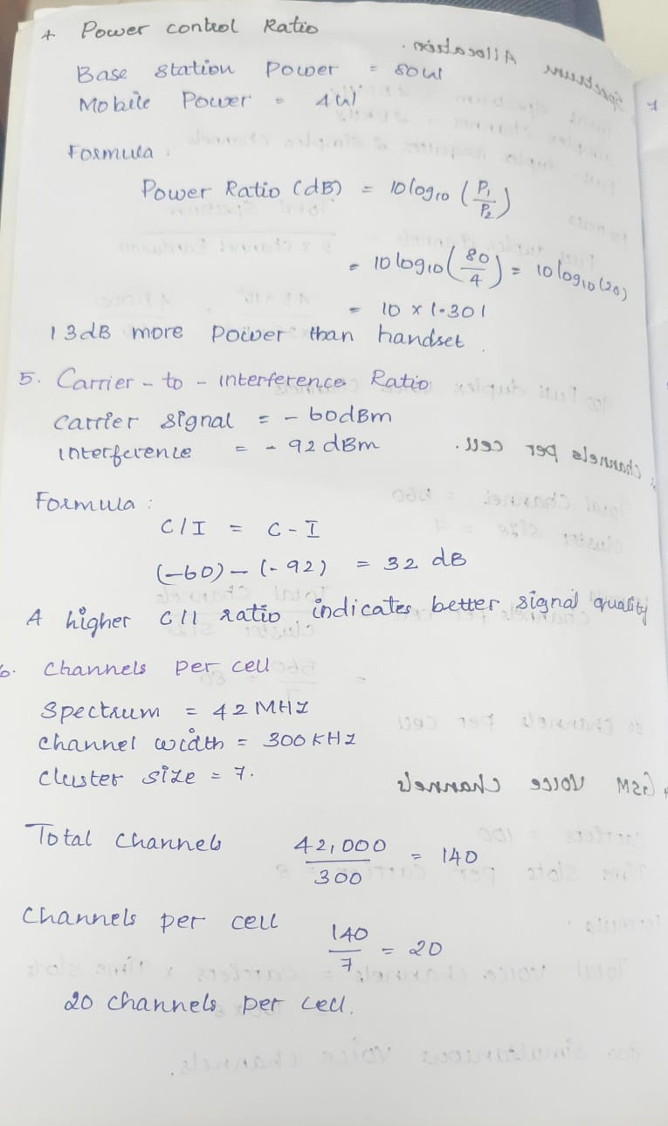
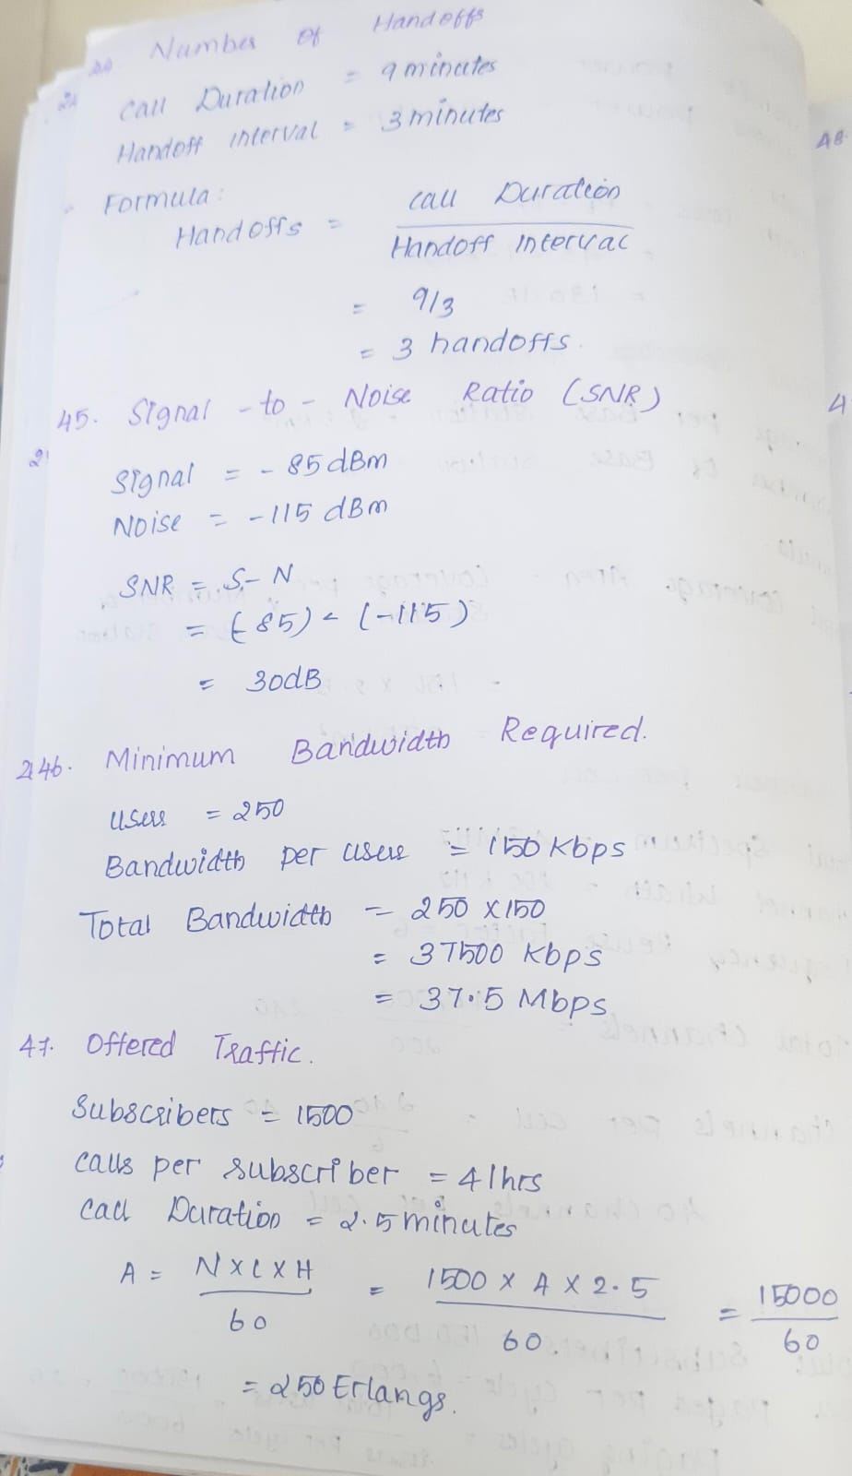


Rubrics for Calculation

Criteria | Weightage | Level 4 – Exemplary | Level 3 – Proficient | Level 2 – Developing | Level 1 – Beginning
Understanding of Concepts | 25% | Demonstrates thorough, accurate understanding of concepts | Good understanding with minor gaps | Basic understanding with some misconceptions | Poor understanding; major misconceptions
Explanation | 25% | Detailed, well-explained answers with relevant examples | Clear explanation with adequate details | Limited explanation; lacks depth | Poor or unclear explanation
Application | 20% | Effectively applies concepts with strong analytical ability | Applies concepts with minor errors | Limited application with weak analysis | No application or incorrect analysis
Organization | 15% | Well-structured answers with logical flow and coherence | Organized with minor issues in flow | Basic structure, lacks clarity | Poor organization, incoherent answers
Accuracy | 10% | Completely accurate and covers all required points | Mostly accurate with minor omissions | Partially correct with missing points | Incorrect answers with major gaps
Clarity | 5% | Clear, neat, professional presentation | Understandable with minor issues | Limited clarity, readability issues | Poorly written, difficult to understand

Faculty In-charge | Course Coordinator | Head of Department
Mrs. B. Abisha | Dr. Terrance Frederick Fernandez | Dr. Sasi Rekha
Signature: _______________ | Signature: _______________ | Signature: _______________
Date: ___________________ | Date: ___________________ | Date: ___________________

